Have You Planned Ahead?
A simple Advance Directive – your needs and wants
If you need help to fill out deniselovelifeoptions@gmail.com

A few simple steps everyone can take
for peace of mind giving time, at a challenging transition in life, to focus on relationships

Have you considered an End-of-life Doula?

deniselovelifeoptions@gmail.com

Legal Medical & Funeral Preferences
Have you planned your legal choices?
It is ideal to set out your wishes in advance. When you better understand your choices and have thought about it, then the end of your life can be easier. Doing this is just actively participating in life.
Make sure family and friends know about your wishes and have a copy of this. Place a note on your fridge about where to find them so if an ambulance officer is looking, it is easy.

Name…………………………………………………………… Birthday………………….……..Date created…………………………
In the event I am unable to express my own needs:
Contacts:
My nominated person to act on my behalf for health decisions....................................................................
Secondary nominated person…………………………………………………………………………………………………………………….
Primary Next of Kin (living blood relative) ........................................................................................................................................................................
Phone and email.............................................................................................................................................
Alternative Next of Kin……………………………………………………………………………………………………………………………….
Solicitor if you have or need one....................................................................................................................
Where will we find your documents
Financial Power of Attorney ...........................................................................................................................
Medical Power of Attorney (this document) ..................................................................................................
Location of Will............................................................................................................................................. ..
Who holds the Pre-Paid Funeral, if you have one?.........................................................................................
Discretionary trust (use or distribute care money) ……………………………………………………………………………………. Social Media Information ...............................................................................................................................
You can write any extra information on the back of this doc. and sign each page to verify it is you
My family
I have dependent people Name……………………………………………………………………………………………………………….
Who I would like to care for them as decisions are being made…………………………………………………………………

My Pets
Name: ………………………………………………………………………………………………………………………………………………….
The person I nominate to care for them whilst decisions are being made for their care or until a forever home can be found………………………………………………………………………………………………………………………………

Have you planned the people to notify?
Employer/s.....................................................................................................................................................
Doctor/s ........................................................................................................................................................
.......................................................................................................................................................................
Health Professionals (e.g., Dentist, Physiotherapist) .......................................................................................................................................................................
.......................................................................................................................................................
Religious leader.............................................................................................................................................
Landlord ........................................................................................................................................................
Government
Centrelink ☐ (132 850) Medicare ☐ (132 011)
Dept Veterans’ Affairs ☐ (133 254) Aus Tax Office ☐ (132 861)
Vehicle Rego & Licence ☐ (131 171) AEC (voting) ☐ (132 326)
Local Council ................................................................................................................................................
Services
Electricity ......................................................................................................
Gas................................................................................................................
Telephone / Internet ..................................................................................
Water ..........................................................................................................
Post Office ....................................................................................................
Newsagent ..................................................................................................
Trade Union .................................................................................................
Clubs & Associations ..............................................................................................................................
Financial
Bank/Credit Union ...............................................................................................................………………………
………………………………………………………………………………………………………………………………………………………………….
Superannuation Fund ...........................................................................................................……………………….
Health Benefits Fund ....................................................................................................................................
Insurance (life, house, car).....................................................................................................………………………
………………………………………………………………………………………………………………………………………………………………….
Life Insurance……………………………………………………………………………………………………………………………………………
………………………………………………………………………………………………………………………………………………………………….
Accountant ....................................................................................................................................................
Financial Planner ...........................................................................................................................................
Charities I donate to………………………………………………………………………………………………………………………………….
Online accounts and to find passwords,, see below or look in ……………………………………………………………………..

Information Required for the Registration of a Death
Full name:......................................................................................................................................................
Address:..........................................................................................................................................................
Occupation when working: ...........................................................................................................................
Sex: .................................... Returned Services: .............................................................
Religion: ............................................... Type of Pension: .............................................................
Date of Birth: ............................................. Place of Birth: ..............................................................
Year arrived in Australia: .................................... State arrived: .............................................................
Father’s Name: ..............................................................................................................................................
Father’s Occupation: .....................................................................................................................................
Mother’s Name: ............................................................(Maiden name): ....................................................
Mother’s Occupation: ...................................................................................................................................
No. of Marriages/Relationships: ................ Present Marital status: ..............................................
1. Where? 2. Where? 3. Where?
Date Date Date
To Whom To Whom To Whom

Names of children (including deceased children) and dates of birth:

Have you Planned your health choices?

Choice of Medical Agent/Medical Power of Attorney.
I understand that my medical agent/medical power of attorney will be able to do the following, if I am not able to:
- Make medical choices for me.
- Agree or refuse treatment for me.
- Interpret instructions on this form for me.
- Make decisions on when to refuse ongoing treatments/life support.
- Authorise release of my medical records if needed.
- Authorise medications and pain treatments for me.
- Communicate my wishes regarding organ/tissue donations.
(I understand I can revoke this authority at any time.)
The person I want to make medical treatment decisions for me is:
Primary Medical Agent/POA (Power of Attorney): Name:..........................................................................
Address: ........................................................................................................................... Phone/s...............................................................................................................................
Secondary Medical Agent/POA: Name ............................................................................
Address: .............................................................................................................................
Phone/s ................................................................................................................................
Person creating this document
Name……………………………………….. Signature…………………………….. Date………………………..
Witness must not be family members
Witness: ................................................ Date: ...............................................
Witness: ................................................ Date ...............................................

The Kind of Medical Treatment I want/don’t want.
I am open to the idea of Death with Dignity (Euthanasia) where it is legal ☐
I have made the arrangements to have this available to me ☐
I choose medically assisted dying if I have an uncomfortable terminal illness ☐
https://www.dwdv.org.au/ read this so you understand.

If I am diagnosed with any sort of Dementia, and my Medical Agent and Doctor deem me to be unable to make decisions, I:
want all treatments available ☐ have arranged for Medically assisted dying ☐
choose not to live a long time with Dementia, so no treatment unless for my comfort ☐
choose no treatment at all for anything please ☐
choose to do whatever my medical agent decides, but I am happy to die ☐
am happy to stay at home as long as possible ☐ would prefer to then live in a care facility ☐ Please avoid a care facility if you can ☐ My desired person or place to live is…………….. ☐
will live wherever is convenient for my caring team ☐
Please use my money and assets to care for me ☐

All illness
If I need life support for some reason for more than an immediate or simple situation, I:
1. Want to have Life Support. ☐
2. Do not want to have Life Support. ☐
3. Want to delegate decisions to my Medical Agent. ☐
If I am in a coma and not expected to wake up or recover, I:
1. Want to have Life Support. ☐
2. Do not want to have Life Support. ☐
3. Want to delegate decisions to my Medical Agent. ☐
If I have permanent and irreversible brain damage and am not expected to wake up or recover, I:
1. Want to have Life Support. ☐
2. Do not want to have Life Support. ☐
3. Want to delegate decisions to my Medical Agent. ☐

Any other conditions under which I do not wish to be kept alive:
General care
Use of Pain killing and comfort drugs Yes please ☐ My body does not tolerate most drugs ☐
I am happy to use cannabis of any sort ☐ Ecstasy ☐ Micro dosing Mushrooms ☐
Negotiate ideal care with my medical Agent ☐
Keep me totally comfortable even if it shortens my life ☐
Awake as much as possible ☐
If I choose to withdraw from food and water, please let me ☐
Please let me die in my own time without pushing me to live ☐

These decisions can be formalised by filling out a Refusal of Treatment certificate in some states, which may be obtained from your GP. Not necessary, but some people feel more comfortable filling in a formal form…. give a copy of this to your GP. Check in your state or country.
Location of Refusal of Treatment Certificate:

Other wishes, need and wants

How I want people to treat me during illness.
If life support treatment will only delay my death, I want Yes No
1. Medical treatment discussions in my room? ☐ ☐
2. Medical treatment discussions with family present? ☐ ☐
3. Medical treatment discussions only with my medical agent? ☐ ☐
4. I want to have people present in my last hours? ☐ ☐
Particular people I would like present: ....................................................................................__ ...........................................................................................................................................................
Particular people I would welcome visits from (priests, colleagues, etc.): ...........................................................................................................................................................
...........................................................................................................................................................
People I would like to exclude please................................................................................................

If it is possible, I want to die at:
1. My Home. ☐
2. Palliative Care/Hospice. ☐
3. Age Care Facility/Nursing Home. ☐
4. Hospital. ☐
5. Not important to me. ☐
My other Preferences:
Organ/Medical Donations: .........................................................................................
.....................................................................................................................................
.....................................................................................................................................
Arrangements for my Pets..........................................................................................
.....................................................................................................................................
.....................................................................................................................................
My Electronic Media Accounts are: ...........................................................................
.....................................................................................................................................
.....................................................................................................................................
Person I authorise to deal with them: ................................................................……
Family & Friends, I would like notified of my illness (name, address or phone):
.....................................................................................................................................
.....................................................................................................................................
...........................................................................................................................................................
...........................................................................................................................................................
...........................................................................................................................................................
Place a copy of your Medical Directive (Health Choices pages 5 -8 of this document) somewhere obvious, with a note on the fridge where it can be found.
Have you Planned your funeral choices?

Did you know you don’t have to have a funeral? You can die at home, have your body in a coffin or wrapped in a shroud and brought home for a family and friends gathering for a day or a few hours and/or you can go straight to the crematorium at minimum cost. Gatherings are often of advantage for the grieving people who care about you. Let them consider this, if you don’t care, at their cost!
Putting what you would want in writing ensures that you get what you would want and takes away later uncertainty at a time when your family is under stress anyway. Issues around recognised partners by family, religious beliefs that differ in families and cultural issues can cause lots of issues at your time of death, if it is not very clear and plain.
Decisions might be big expensive ones – like where to purchase a single grave or a double grave – or small simple ones – like which song could be played.
- Pre-Arranging a funeral involves sorting out the details amongst the family beforehand
- Pre-Payment takes pre-arrangement to the next level and invests for the planned funeral at today’s prices. This can be done up front, or on a payment plan, and the funds are securely invested. (This option also reduces assessable assets for calculating pension payments). It is in the form of a bond and is transferable between funeral homes.
- Funeral Insurance (which is often advertised as an alternative to pre-paying a funeral), should probably be treated with caution.
Funeral Type
Home ...................................................................................................................

Funeral location: ....................................................................................................................

Burial ☐ Cremation ☐ Aquamation ☐ Natural burial ground ☐

Grave Location: ........................................................................................................................

Ashes instructions:

Funeral
- I would like an Eco-friendly funeral please. All natural fibres, and products please ☐
- I would like a mostly Green funeral ☐ I don’t care ☐
- Stay at home after I die ☐
- Take me home for a vigil, people sitting with me 4 hours ☐ 1 day ☐ 3 days ☐ up to you ☐
- I would like a vigil at the Funeral home ☐
- Please leave my body to rest, I am fine on my own to allow the time I need to finish life ☐
- Hire a cold plate or blanket ☐ Just use dry ice or frozen hot water bottles ☐
- Leave me in the clothes I die in ☐
- Dress me in special clothes which I have picked ☐
- Wash my body ☐ Face and hands only ☐ clean me up if I need it ☐ No wash ☐
- Shroud only, no coffin ☐
- Wrap me gently in a cotton sheet as a shroud ☐
- Place me in an open coffin ☐
- Place me in a closed coffin at home ☐
- Let the funeral home care for me but no extras ☐
- Just have a normal funeral, whatever that is ☐
- No embalming please ☐
- No mouth stitch please ☐
- My choice of coffin is As green as possible ☐ Anything my family chooses ☐
Untreated pine ☐ Cardboard ☐ Homemade ☐ Wool ☐ Wicker ☐ Shroud ☐
If you choose a conventional funeral, then it is best to find an independent funeral director who is able to service you with caring, cost-effective services. There are plenty. Just be aware that many funeral directors are part of a huge international organisation and are less likely to individualise your needs.

All the coffins suggested can be painted, lined and decorated. You can place a sheet-shrouded person inside and have the coffin at home to decorate in advance, as someone is dying or anytime you wish. Independent funeral directors will support you if you require transport, help dressing or organising things. There are many wonderful, supportive Funeral Directors available.

Songs I would like played or sung:

Readings Reading: Reader:
1st .................................................... …..................................................
2nd .................................................... …..................................................
Other .................................................... …..................................................
Pallbearers .......................................................................................................................
…………………………………………………………………………………………………………………
………………………………………………………………………………………………………………..

Poem or Reflection: ......................................................................................................................

Refreshments at: ....................................................................................................................

Special instructions: ...................................................................................................................

. .................................................................................................

Other Requests:

Music at Graveside: ......................................................................................................................

Ashes Instructions: .......................................................................................................................

Special instructions: .......................................................................................................................

......................................................................................................................

........................................................................................................................
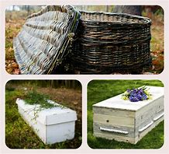
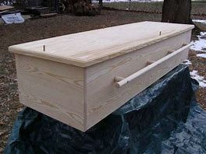

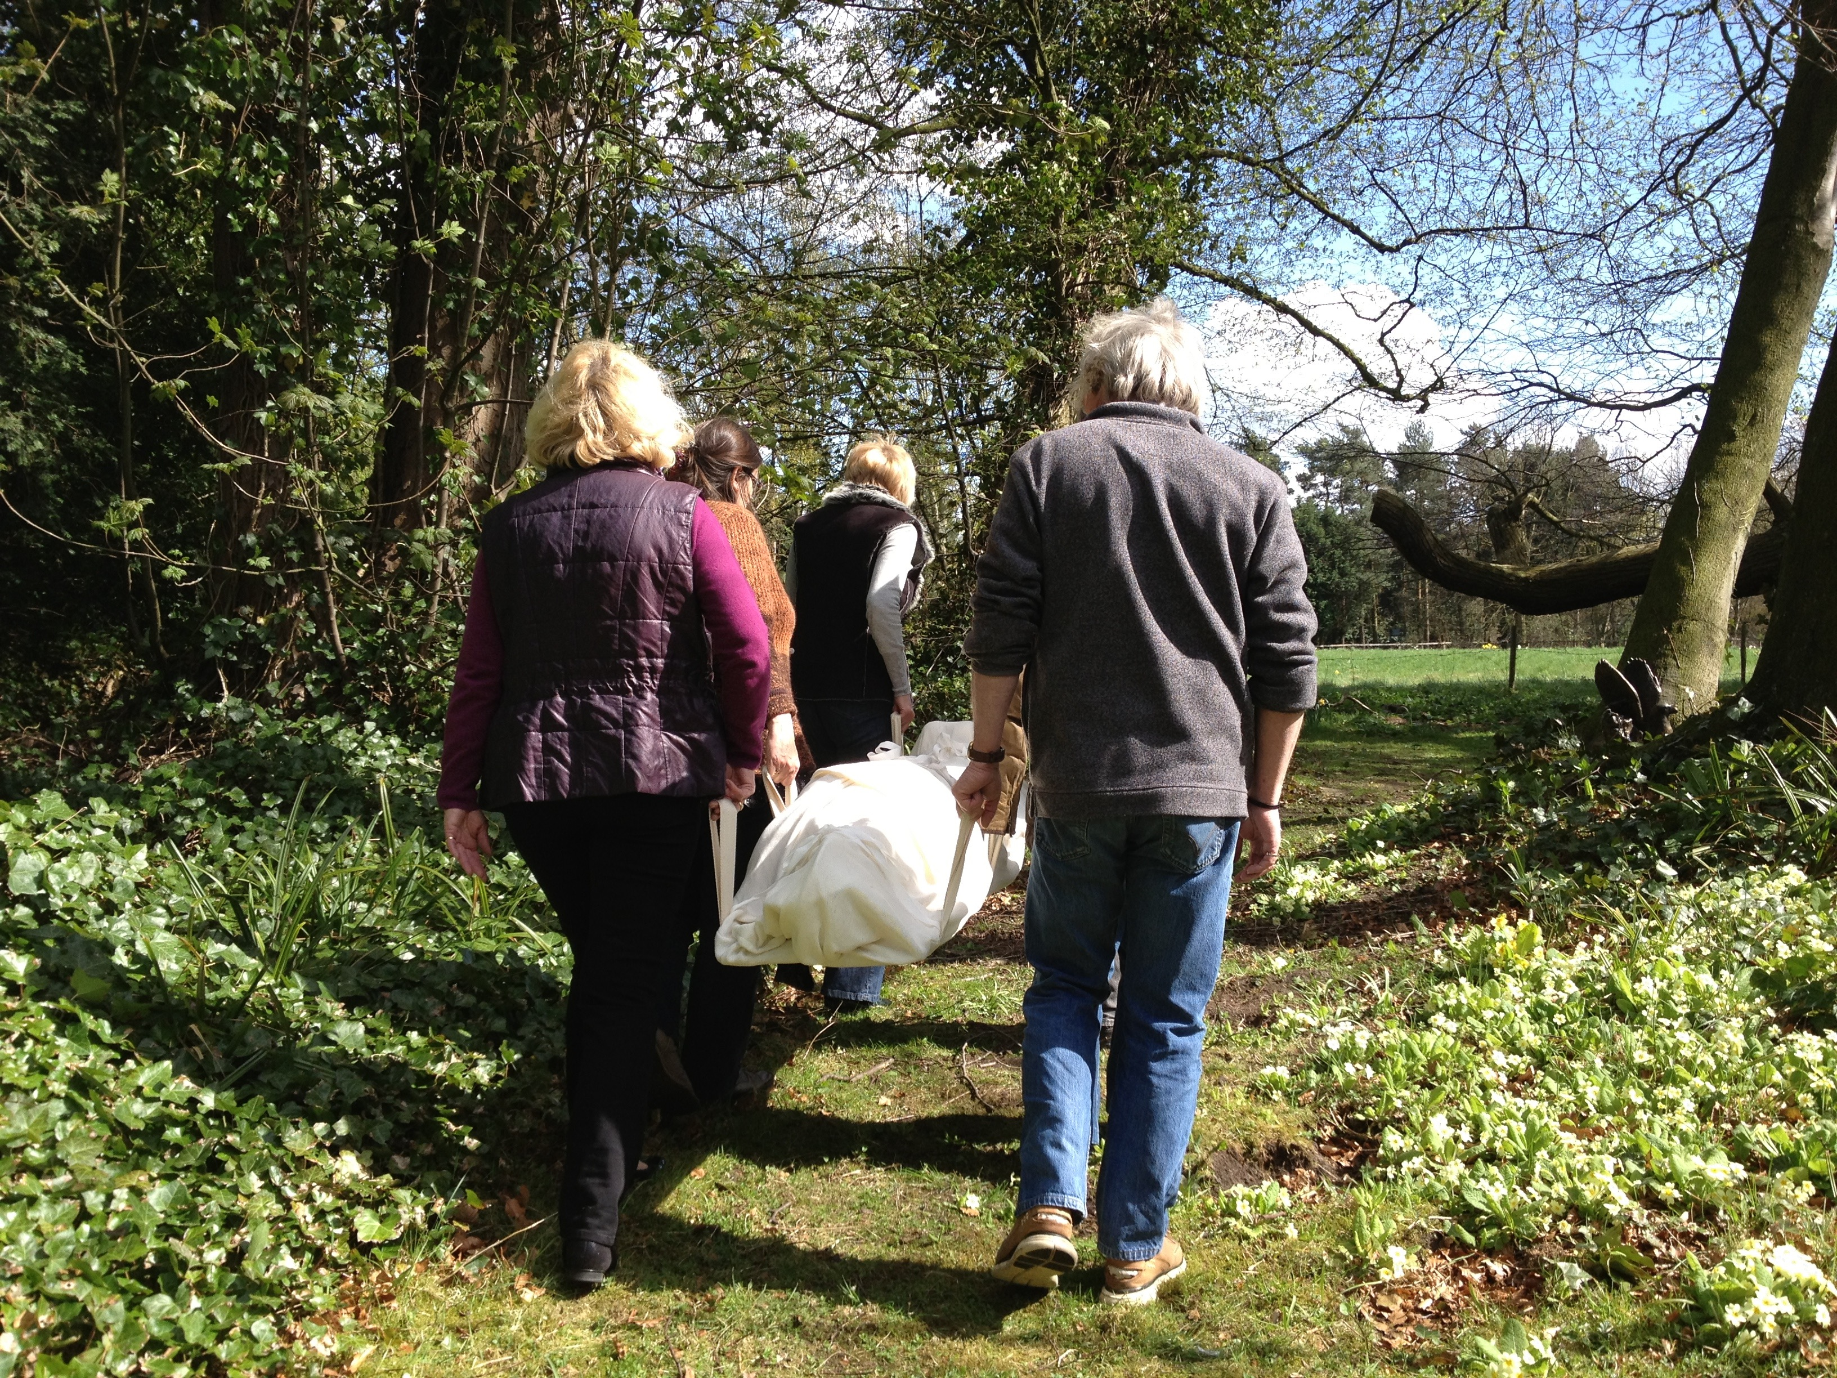
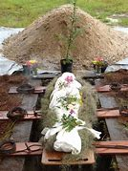

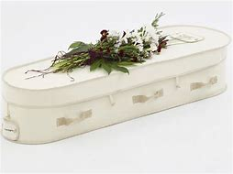
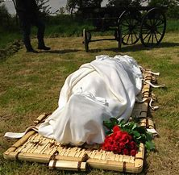
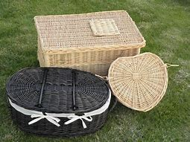

By taking responsibility for your life now, means your end-of-life is less challenging.
You can embark on living fully until you die……Death is not the enemy, not living life fully is.

