Hello

Open Denise Chat

https://www.dropbox.com/s/xjmw3hzry947ls7/1%20How%20it%20unfolds.mp4?dl=0

1. Foundation Death Doula Training Cost: $590

Method of Study: Online

- 10 Modules. Weekly Zoom meetings aligned with the modules. Zoom meetings are recorded, so you have the choice of how you study. We suggest doing 4 hours study a week to complete in minimum time, but you have 6 months to complete.
- Go to page 3 to see how it unfolds.

Face to face Foundation Training 2-day intensive $490

2. Advanced Death Doula Training Cost: $590

Method of Study: Online
- Online Foundation Training - 10 Modules. Weekly zoom meetings aligned with modules. Zoom meetings are recorded, so you have the choice of how you study. We suggest doing 4 hours study a week to complete in minimum time, but you have 6 months to complete.

Advanced Death Doula Face to Face Training - watch this space….it will unfold when we all have freedom of movement.

3. Mammas and Babies Death Doula Training Cost: $390

Method of Study: Online
A series of 5 modules with weekly Zoom sessions. Can be completed with approximately 4 hours’ study per week, OR within 6 months. Zoom meetings are recorded, so you have the choice of how you study.

- Pet Death Doula Cost: $390

Method of Study: Online
A series of 5 modules with weekly Zoom sessions. Can be completed with approximately 4 hours’ study per week, OR within 6 months. Zoom meetings are recorded, so you have the choice of how you study.

Doula Companion Volunteer FREE

This is just for volunteering in Aged Care Facilities and is only for volunteers

Method of Study: Online
A series of 4 modules with weekly Zoom sessions. Can be
completed with approximately 4 hours’ study per week,
OR within 6 months. Zoom meetings are recorded,
so you have the choice of how you study.
To enquire about dates email gazzalove@gmail.com

Registration and payment: all courses
- Register at: gazzalove@gmail.com for all courses
- A $90 deposit will hold your place
Payment click here https://paypal.me/mummadoula?locale.x=en_GB. Don’t be alarmed at recipient currency being in Thai Baht. Most of our charity work is in Asia.

Who will benefit from this training?
- Anyone who wishes to learn more about cultivating presence and personal awareness in death, dying and living well
- People facing a terminal illness
- Friends and family caring for someone who is dying
- Those who want to accompany someone special in their lives through this process
- Allied health professionals working in hospices, hospitals or nursing homes who are seeking to expand their skills and effectiveness in assisting with death and dying
- Healers and therapists who want to learn more and expand their skills base
- Hospice volunteers or those wishing to become volunteers
- Those who want to prepare gracefully for their own journey through dying and into death

- Anybody who wishes to challenge traditional death and funeral practices and find a cost-effective green way to die

‘We laugh, cry and deeply think about our lives, living with intention
and make choices that work for us at the end of our lives on earth’

In Australia, and most countries I have lived and taught in, not so long-ago people were born, and died in their own homes, with family and friends providing care for them. These were community events with friends and neighbours gathering and supporting the families. This created a feeling of acceptance that, like birth, dying is a natural life transition. The dead person lay in their own home from 1-3 days and people came and went. It was just part of life. Women gathered and cooked and drank tea. Men sat and talked and usually drank alcohol and told stories.
Over the past 60 years, the care of our dying and dead has gradually been handed over to hospitals and funeral directors. Dying of a terminal illness is usually not an emergency but is often treated as one. Intensive care facilities are overrun with people ‘wanting to do everything they can’. Despite this eventuation, there can be release in surrender to the inevitable. If a compassionate and skilled person helps you to see the limitations of medicine and that acceptance of death as a part of life is a positive move, it reduces the fear of ‘what might happen’. This is where Death Doulas step in in order to fill the gap between over medicalisation and intervention and facing death calmly and well supported. Recent times have seen a resurgence in families providing end-of-life care at home or sitting in hospices with their friends and relatives. When people are guided and supported they feel empowered to do the caring themselves. This allows connection, time to begin the grieving process, time to talk and share thoughts and feelings. Or, even if relationships are not ideal, a feeling of caring can be fostered. Healing of relationships may even take place. This is highly beneficial to the post death grieving process.
There is a strong movement to ‘green’ care and green funerals which includes the reduced use of drugs, waste and toxic chemicals. This creates many challenges due mainly to our lack of extended families and older people (wise elders) who would have otherwise taught us how to do death well.

Many are choosing nonconventional healing methods and are teaching us the possibilities…I will share what I know with you.
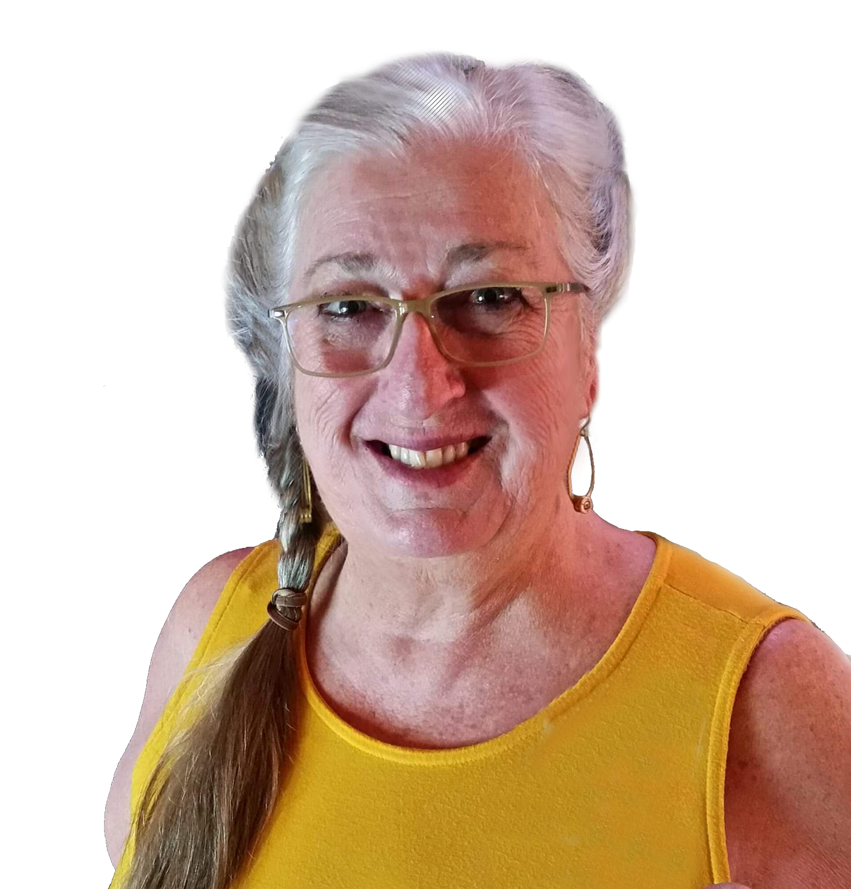

How it unfolds

Your Facilitators: Denise Love

I started my professional life as a Registered Nurse and very quickly discovered that it wasn’t the medicines I offered to people that were the most beneficial, but the kindness provided that supported healing, or made death more tolerable. Following that discovery, I began midwifery training, and again it was confirmed that being ‘present’ with someone
had a much greater impact on wellbeing than most ‘treatments’.

Throughout the 1990’s I set up a Home Palliative Care service where often one of the only ‘tools’ I had for comfort and care was ME. I then worked in a palliative care team with a wonderful doctor as more and
more treatment around cancer became available, alleviating symptoms and discomforts, and better understanding the use of morphine. I began reflecting on my time working in remote Indigenous Australia in the 1970’s, where their traditional carers had just been ‘present’ and had allowed the transition into death as a simple process. They sat around and shared stories, told tales, cried and offered simple comfort. They also understood withdrawal of food and water and were not scared to let it happen…. It was profound!

A non-medical role appealed to me and I became a Doula - of service to people. With the understanding that I needed to take responsibility for what happens in my life, the words that come out of my mouth, and the reality that everybody has the right to live their life their own way, I set up a full-time Doula Service for Birthing and Dying people and facilitated learning around that.

I have been with many, many people as their Death Doula and continue to do so face to face, online and in many countries. I have supported mothers of dying children so they could rest and have time to get their head around what was happening in their world; birthed beside women whose babies died in utero; held the hands of old people who were too scared to let go - for endless days. I have discussed the concepts of heaven and hell with many people dying; worked out ways to avoid ever seeing a doctor and avoid a post-mortem for people who do not use the traditional medical system. I have held babies as they die in the first few weeks of life and talked to them about what is happening, when parents weren’t able to.

I currently work in remote areas of developing countries where we face death with no options. Quite regularly
I talk with families about how best to let their elder family members go. I discuss with others how best to let their too little, or sick baby die, and the realities around that in an emotional and comfort sense. I meet with whole villages as a tragic accident occurs. I am with families when someone has suicided, and they try and make sense of it. I ‘hold the space’ as people come to their own realisations and offer solutions to their queries that might be suitable for them. But most of all, I just keep turning up with a hug, a smile and with no agenda to do anything.

We are Death Doulas or End-of-life Consultants - offering a different service to medicalised care. Palliative care is offered by medical staff, but this often does not allow the time needed to be ‘present’ with someone dying. The dying process is eased substantially by comfort, presence and emotional or spiritual support.

As I am now an elder in the community and needing some time to be a mother, grandmother and partner, I share my role with Barb Ferguson. We have worked side by side for some time now and delighted I can share her with you.

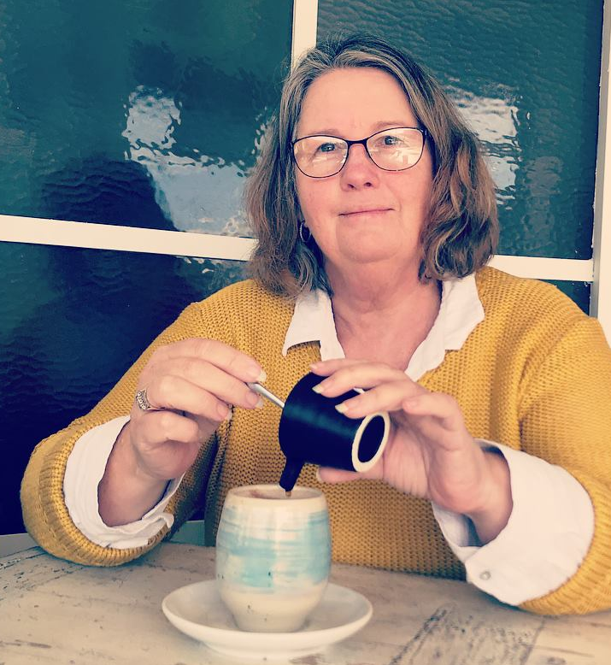
Barb Ferguson
I like to start this part of the story with, in a former life I was an accountant and as there are only 2 certainties in life that’s death and taxes working with death is a natural following career to accounting.
Like all of us my whole life was a precursor to finding and following my heart work as a doula, I was blessed with so many experiences along the way putting it in place piece by piece. My path into doula training was as a birth doula, it was during this training though that I realised quickly that I was unprepared should I be asked to support a family through miscarriage, stillbirth or neo natal death this is when my world collided with Denise Love.
Denise became my mentor and we soon worked together when Denise’s schedule took her out of the country and families needed a presence, as Denise has mentioned I’m Hyper-mobile with a grown family of 3 around Melbourne and Amsterdam you’re never sure where I will pop up.
Personally, I’ve enjoyed so many opportunities through my life to engage in personal development, leadership training and of course any training that pops up in relation to doula work so my ability to handle many different

situations is often sought out.
Soon after my birth doula training I became a volunteer with Birth for Humankind in Melbourne, Australia. This organisation supports women from diverse backgrounds to navigate the Australian health system so it’s been my privilege to support over 60 families welcome their babies earth side, when I started embracing my death doula work I would often be at a birth and death in quick succession and realised how close both events are in dynamics, the more you trust a birthing mother to know her body and baby the more you see similarities in death work.
I offer my families a calm presence and can maintain strong boundaries without families being aware, so that they feel very supported during our encounter, to this end I’ve also gained lifelong supporters of my work and feel comfortable that when there is a need the support will be at hand.
I’ve relished opportunities to share my knowledge in the past and joined Denise on many occasions whilst she shared her teachings, so when Denise was recently incapacitated I nervously stepped up and facilitated her weekend training.
The world of death and similarly birth has been taken out of the homes, medicalised and placed in the shadows I feel, like Denise, that an important part of our work is to sing about how natural and beautiful death and birth can be, to remove the fear and embrace the beauty of home care, vigils and family led funerals and gatherings to offer options that encourage families to embrace one another and move with death/birth rather than against.
I look forward to sharing this with you in the future and thank Denise and Gary for the welcome into the LifeOptions family and for all the pioneering work done by them both to create a wonderful legacy (still in progress) in the Doula world.

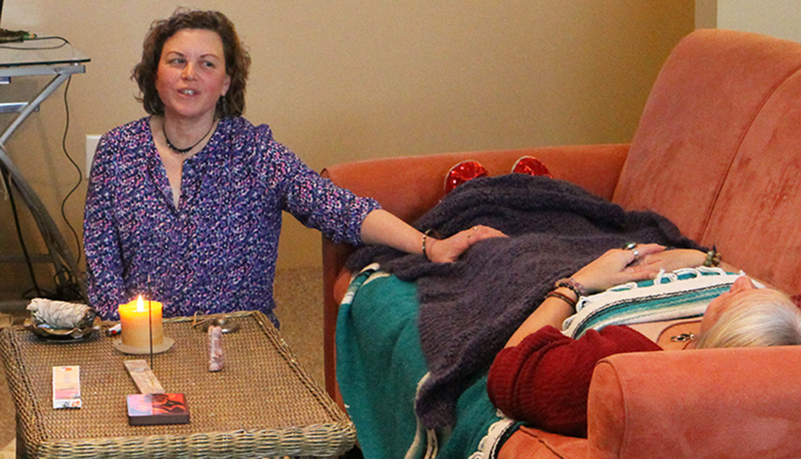

Death Doulas fill the gaps

The word Doula

Many people associate the term ‘doula’ with a midwife, due to the growing doula movement which provides
support and advocacy for expecting mothers, and new parents. Doulas offer no medical services. We support women and midwives in their important relationships during birth. Like birth Doulas who help pregnant and birthing women, Death doulas who help and support the dying and their families regard their work as equally important. Death doulas provide a range of services dependant on our individual skills and the needs of our clients. These skills incorporate both professional skills or qualifications and (if you have them), ‘life-long learning’ skills, which Death Doula education will help you recognise deep inside you. Death Doula care is somewhat intuitive care, utilising our heart, hands, mind and soul. It is an extraordinary life experience in which we honour all cultural and spiritual beliefs. We sit with a dying person and remain with them after they have died. We top up the families’ courage to do this wonderful work. We do anything from helping arrange ceremonies and rituals and vigils to dealing with services, allied health and Funeral Services. Many Doulas stay to assist throughout the funeral, and some do follow-up visits with family members in the weeks and months after the death to talk about the experience. Each relationship will develop as needed and depending on what the dying persons’ family requires.

A Doula is willing and able to give, listen and act
So how does this unfold? How do I get to be this person?
- You will explore why you came to do this course
- We will look at fear and how that manifests in our lives
- You will begin to develop skills to help the people around you explore the word ‘death’
- You will better understand end of life choices that are available to people: End-of-Life/Advanced Directives
- There will be discussion about Funeral Planning, Green Funerals and Burial
- You will develop a passion for living fully until you die
- Learn to support those around you to live today as if it was the last day of your life
- You will develop a bucket list for yourself to complete before you die
- Your life skills will be enhanced so that you can be fully ‘present’ with others
- Strengthen your capacity to be empathic and build strong boundaries in order to care for yourself
- You will discuss the family dynamics that occur as someone dies
- Learn tools for creating a sacred space for transition, before and after death
- Create your own guidebook to use with patients or for home funeral vigils
- Look at funerals, and how to personalise, simplify and cost less.
- Above all, you will enhance your own life!

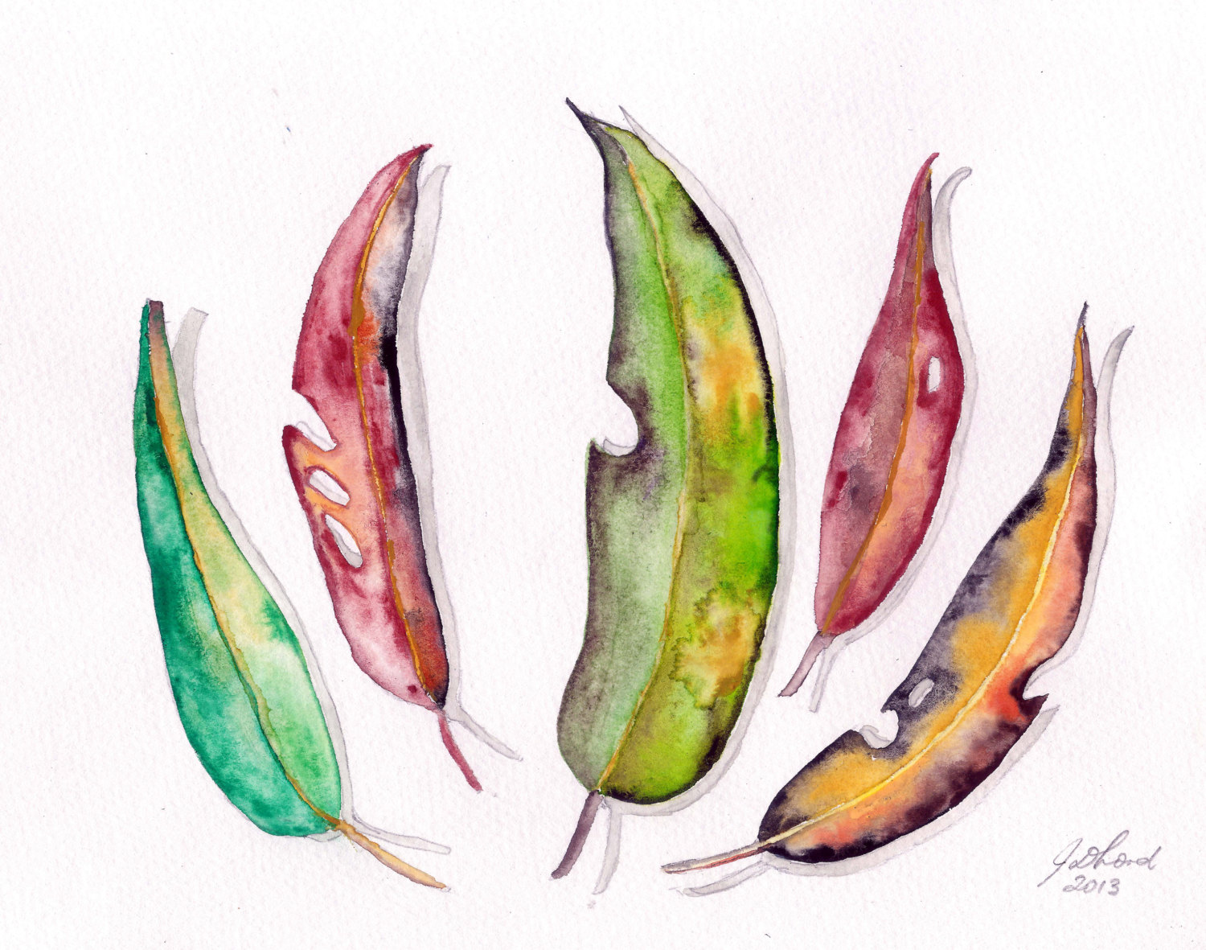

‘The focus of our work is on the journey of life leading to death.
of living life to the fullest freeing, ourselves of fear.

We enable people to feel safe to have the ‘death conversation’. The experience of grief challenges our deepest sense of who we are’

- Pay the $90 deposit or full fee for the course; click here https://paypal.me/mummadoula?locale.x=en_GB. Don’t be alarmed at recipient currency being in Thai Baht. Most of our charity work is in Asia. Payment plans are available.
- The remaining balance is payable before the commencement of the course
- A Facebook study group will be set up as a study group page where you can chat, share stories, and look for support, etc.
- You are asked to introduce yourself to the group where you will be offered a link to Zoom sessions online training. Simply download the Zoom app…search in Google for this, form an account, and you are ready to go…the same link is used at the same time each week.
- You will be added to the study group where you can access pre-reading to get your mind and heart ready

- Gary Love, my husband and one awesome man, will communicate with you on gazzalove@gmail.com
- Around 15 people will be in each group, so you can communicate easily
- On a nominated date of the course, Module 1 will be posted for you to download from Dropbox and each Module will be weekly thereafter. You don’t need to have a Dropbox account. Simply press the link and go to “go to website” …. computer is more seamless than phone.
- At the end of each module, return the Reflection sheet as acknowledgement that you have completed the module. Please email to: doulabarblifeoptions@gmail.com

When you open the Dropbox link in the study group, there will be the following:

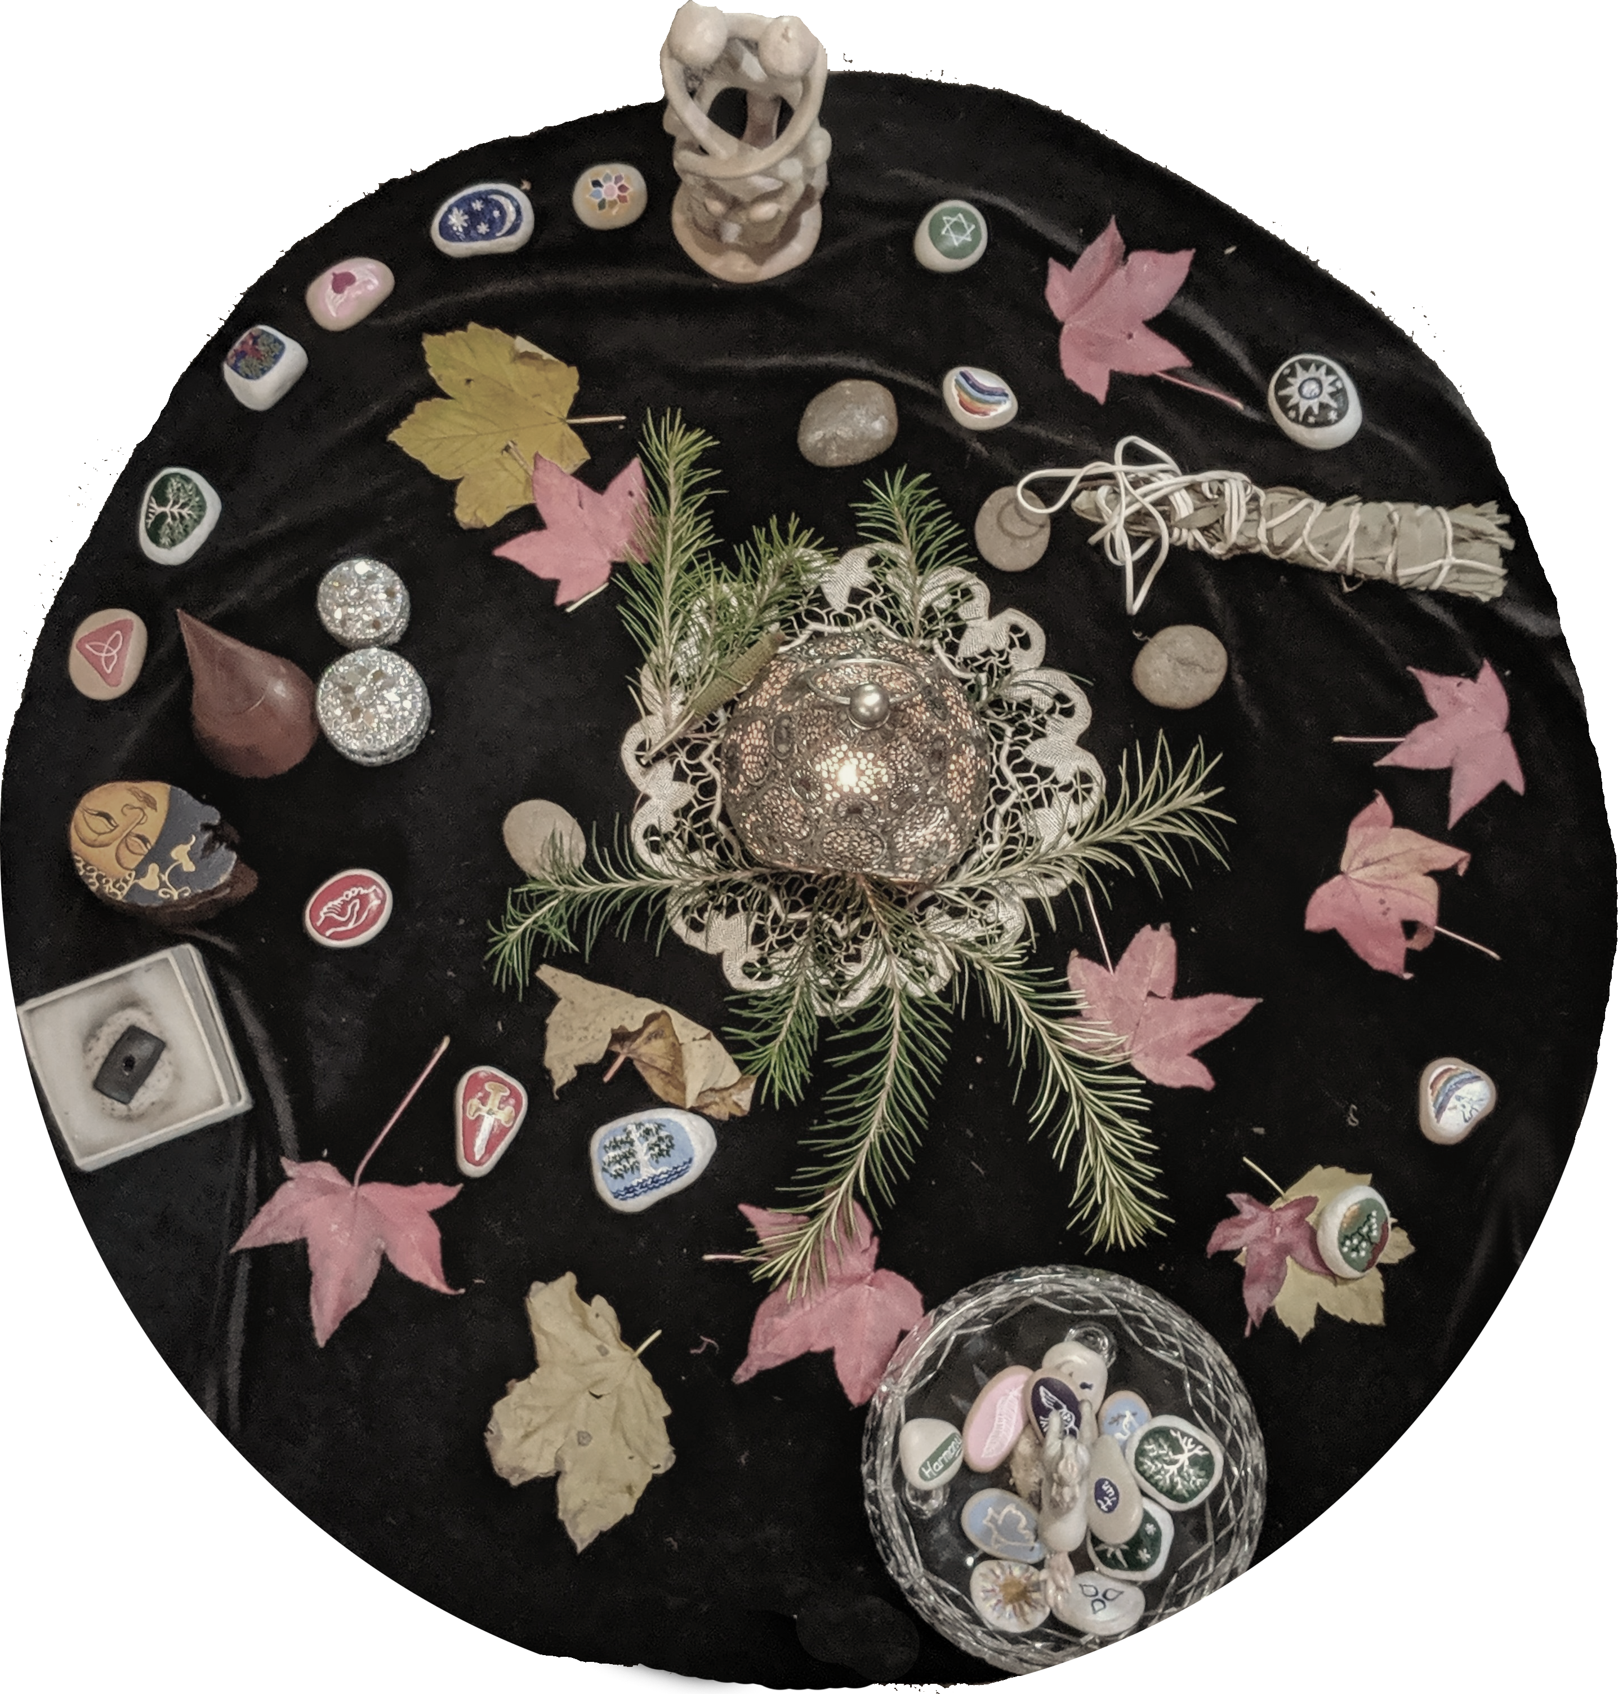
  - Start here
  - Reading
  - Watching
  - Listening

You will be directed what to watch or listen to and when

You will be working as a Death Doula and Private Practitioner, offering all the lifelong skills you have developed, and using your deep inner knowledge and instincts.

- Within 6 months the course is to be completed, unless an extension is arranged
- The aim is to awaken your inner knowledge, compassion, kindness and a willingness to serve with an open heart and mind, giving people the space to live their lives in the full circle of life
- You are asked to serve 2 people for free as a Trainee Death Doula as part of the course, but this can be done outside the 6 months
- You will be issued with Death Doula Certification from LifeOptions on completion of the Modules
- LifeOptions is An International Training Body with a track record of 25 years

Foundation Outline

Module 1
- Talking about death and Dying
              - Walking the path of a death Doula
              - The skills you need
              - Beginning of developing those skills
              - Moving towards Mastery – Listening
- Getting started
- Being of service
- Reflection

Module 2
- Dealing with Fear
- Advance Care Directive – choices available and filling out your own
  - Green and Home options
  - Traditional choices
  - No treatment choices
- Dealing with the death of a special person
- Do’s and Don’ts suggestions for friends and family when dealing with Bereavement
- Healing the past and present
- Ways to forgive a person you are challenged by
- Healing session – letting go

Module 3
- Learning about ‘being of service’
- Conflict resolution
- Everybody will have their centre stage – let the dying person have theirs
- Watch your language
- Honesty
- Reflection

Module 4
- Staying in the moment
- Getting your affairs in order
- Tools to help organise your final needs
- Funeral planning – choices of simple sheet wrapping to green coffins
- Home Death and Green funerals
- Revisiting the Advance Directive
- Wishes and Treatment choices

Module 5
- Supporting the person to live until they die
- Surrendering to death
  - Getting close to the end
  - Urgency and how to work with someone who has little time
  - Die prepared
  - When Death seems to be the hardest work
3.We need to talk
4.Digital demise
5.Recognising the dying process
6.The tasks of dying
7. The weeks following death journey’s end
8.The death of pets

Module 6
- Moving on
7. Ashes
8. Life after death?
9. Children dying at home
10. Music and Poetry
11. Gratitude

- Dealing with the body
- Funeral Parlours
- Disposal of the body
- What happens after someone dies?
- Coffins

Module 7
- Looking at grief
- When you are working with an analytical mind

Module 8
- The business of a Death Doula
- Setting an intention for your Death Doula Practice
- The beliefs of people who live a satisfying life and step into it fully
- Stepping into your Death Doula Practice
- Vision
- Marketing strategies

Module 9
- Living life fully
- Death in the 21st century
- The most common causes of death in Australia

Module 10
- Clarifying thoughts and feelings
- Developing emotional freedom
- Getting started – tools to make it happen
- Death Literacy
- Conversation cards

Welcome each transition in life, and step into it fully!

